Lab Practical #07:
Develop mobile or web screen of product listing and product detail screen.

Practical Assignment #07:
Develop mobile or web screen of product listing and product detail screen.

Description:
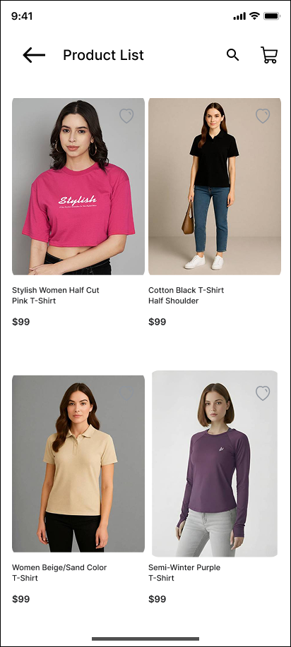

Product List Page

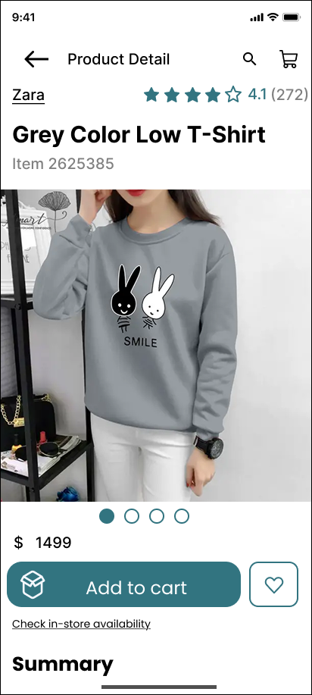

Product Detail Page

